bulk export of rdl's using powershell
Yes. Since your reports are currently on Power BI Report Server (PBIRS) and you want to migrate them to Power BI Service, you can bulk-export the .rdl files with PowerShell.
For PBIRS, the cleanest current approach is to use its REST API. Microsoft documents that the PBIRS REST API can navigate the catalog and download report definitions, and the API supports folders, reports, data sources, datasets, etc.

Recommended approach
Power BI Report Server
│
│ REST API
▼
PowerShell Script
│
├── Folder 1
│ ├── Report1.rdl
│ └── Report2.rdl
│
├── Folder 2
│ ├── Report3.rdl
│ └── Report4.rdl
│
└── ...
│
▼
Local RDL Repository
│
▼
Azure DevOps Git

1. First identify your PBIRS REST endpoint
Suppose your PBIRS server is:
https://PBIRS01
The REST API is generally exposed under:
https://PBIRS01/reports/api/v2.0
Microsoft's PBIRS REST API uses endpoints such as Reports, CatalogItems, and CatalogItems({Id})/Content/$value.

2. Test that PowerShell can see your reports
Start with:
Method1: Using Default Credentials
$PBIRS = "https://PBIRS01/reports"

$uri = "$PBIRS/api/v2.0/Reports"

$response = Invoke-RestMethod `
-Uri $uri `
-UseDefaultCredentials `
-Method Get

$response.value | Select-Object Id, Name, Path
If Windows authentication is configured and your account has access, you should get something similar to:
Id Name Path
-- ---- ----
a123... Sales Report /Finance/Sales Report
b456... Invoice Report /Finance/Invoice Report
c789... Customer Report /Sales/Customer Report
The PBIRS REST API exposes report catalog information and allows programmatic access to report definitions.
Method 2: Prompt for Credentials
$PBIRS = "https://PBIRS01/reports"

# Prompt for username and password
$Credential = Get-Credential

$uri = "$PBIRS/api/v2.0/Reports"

$response = Invoke-RestMethod `
-Uri $uri `
-Credential $Credential `
-Method Get

$response.value | Select-Object Id, Name, Path

My workings:
Method 1:
$PBIRS = " https://elgi-bis.elgi.com/reports"

$uri = "$PBIRS/api/v2.0/Reports"

$response = Invoke-RestMethod `
-Uri $uri `
-UseDefaultCredentials `
-Method Get

$response.value | Select-Object Id, Name, Path
Output:
Missed to add https:// in the Url, hence got the below error
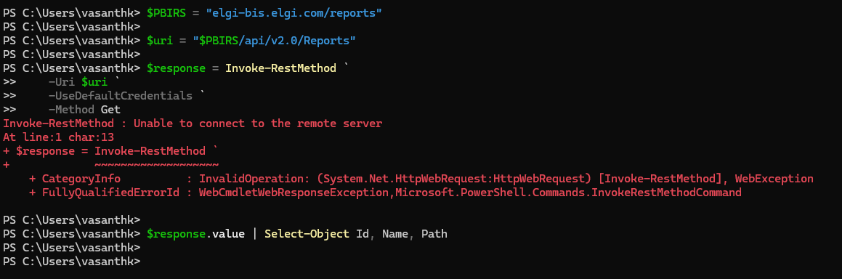
After correcting it,
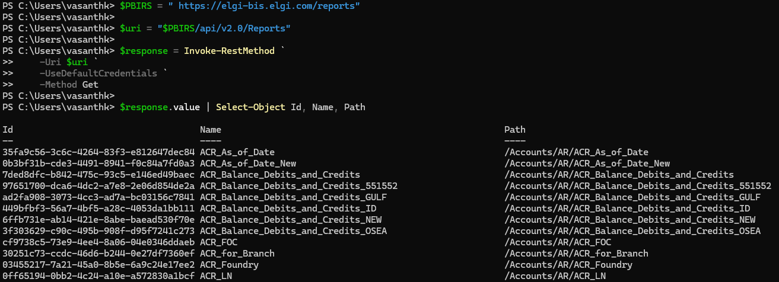

Method 2: Not tried out
$PBIRS = " https://elgi-bis.elgi.com/reports"

# Prompt for username and password
$Credential = Get-Credential

$uri = "$PBIRS/api/v2.0/Reports"

$response = Invoke-RestMethod `
-Uri $uri `
-Credential $Credential `
-Method Get

$response.value | Select-Object Id, Name, Path

3. Bulk download all RDLs
Once the test works, you can use:
$PBIRS = "https://PBIRS01/reports"
$OutputFolder = "C:\PBIRS-RDL-Export"

New-Item -ItemType Directory `
-Path $OutputFolder `
-Force | Out-Null

# Get all reports
$uri = "$PBIRS/api/v2.0/Reports"

$response = Invoke-RestMethod `
-Uri $uri `
-UseDefaultCredentials `
-Method Get

foreach ($report in $response.value) {

$reportName = $report.Name
$reportId = $report.Id

$safeName = $reportName -replace '[\\/:*?"<>|]', '_'

$outputFile = Join-Path `
$OutputFolder `
"$safeName.rdl"

Write-Host "Downloading: $reportName"

$contentUri =
"$PBIRS/api/v2.0/CatalogItems($reportId)/Content/`$value"

Invoke-WebRequest `
-Uri $contentUri `
-UseDefaultCredentials `
-OutFile $outputFile
}

Write-Host "Export completed."
This gives you:
C:\PBIRS-RDL-Export
│
├── Sales Report.rdl
├── Invoice Report.rdl
├── Customer Report.rdl
├── Finance Report.rdl
└── ...

My workings

$PBIRS = " https://elgi-bis.elgi.com/reports"
$OutputFolder = "C:\PBIRS-RDL-Export"

New-Item -ItemType Directory `
-Path $OutputFolder `
-Force | Out-Null

# Get all reports
$uri = "$PBIRS/api/v2.0/Reports"

$response = Invoke-RestMethod `
-Uri $uri `
-UseDefaultCredentials `
-Method Get

foreach ($report in $response.value) {

$reportName = $report.Name
$reportId = $report.Id

$safeName = $reportName -replace '[\\/:*?"<>|]', '_'

$outputFile = Join-Path `
$OutputFolder `
"$safeName.rdl"

Write-Host "Downloading: $reportName"

$contentUri =
"$PBIRS/api/v2.0/CatalogItems($reportId)/Content/`$value"

Invoke-WebRequest `
-Uri $contentUri `
-UseDefaultCredentials `
-OutFile $outputFile
}

Write-Host "Export completed."

4. Better version — preserve PBIRS folders
For your migration, I strongly recommend preserving the folder structure.
For example, if PBIRS contains:
/Finance
/Monthly
Sales.rdl
Revenue.rdl
/Annual
AnnualSales.rdl

/HR
Employee.rdl
Payroll.rdl

/Sales
Customer.rdl
your export should produce:
C:\PBIRS-RDL-Export
│
├── Finance
│ ├── Monthly
│ │ ├── Sales.rdl
│ │ └── Revenue.rdl
│ │
│ └── Annual
│ └── AnnualSales.rdl
│
├── HR
│ ├── Employee.rdl
│ └── Payroll.rdl
│
└── Sales
└── Customer.rdl
This is much better for your subsequent Azure DevOps migration.

5. PowerShell script preserving folders
I would use this version for your project:
$PBIRS = "https://PBIRS01/reports"

$OutputFolder = "C:\PBIRS-RDL-Export"

New-Item `
-ItemType Directory `
-Path $OutputFolder `
-Force | Out-Null

Write-Host "Connecting to Power BI Report Server..."

# Get reports
$uri = "$PBIRS/api/v2.0/Reports"

$response = Invoke-RestMethod `
-Uri $uri `
-UseDefaultCredentials `
-Method Get

$reports = $response.value

Write-Host "Reports found: $($reports.Count)"

foreach ($report in $reports) {

$reportName = $report.Name
$reportId = $report.Id
$reportPath = $report.Path

Write-Host ""
Write-Host "Processing: $reportPath"

# Remove report name from path
$folderPath = Split-Path `
$reportPath `
-Parent

# Remove leading /
$folderPath = $folderPath.TrimStart('/')

# Create local folder
if ([string]::IsNullOrWhiteSpace($folderPath)) {

$localFolder = $OutputFolder

}
else {

$localFolder = Join-Path `
$OutputFolder `
$folderPath
}

New-Item `
-ItemType Directory `
-Path $localFolder `
-Force | Out-Null

# Clean filename
$safeName = $reportName `
-replace '[\\/:*?"<>|]', '_'

$outputFile = Join-Path `
$localFolder `
"$safeName.rdl"

# Download RDL
$contentUri =
"$PBIRS/api/v2.0/CatalogItems($reportId)/Content/`$value"

try {

Invoke-WebRequest `
-Uri $contentUri `
-UseDefaultCredentials `
-OutFile $outputFile

Write-Host `
"SUCCESS: $outputFile" `
-ForegroundColor Green

}
catch {

Write-Host `
"FAILED: $reportPath" `
-ForegroundColor Red

Write-Host $_.Exception.Message
}
}

Write-Host ""
Write-Host "================================"
Write-Host "RDL Export Completed"
Write-Host "Output: $OutputFolder"
Write-Host "================================"

My Workings

$PBIRS = " https://elgi-bis.elgi.com/reports"

$OutputFolder = "C:\PBIRS-RDL-Export"

New-Item `
-ItemType Directory `
-Path $OutputFolder `
-Force | Out-Null

Write-Host "Connecting to Power BI Report Server..."

# Get reports
$uri = "$PBIRS/api/v2.0/Reports"

$response = Invoke-RestMethod `
-Uri $uri `
-UseDefaultCredentials `
-Method Get

$reports = $response.value

Write-Host "Reports found: $($reports.Count)"

foreach ($report in $reports) {

$reportName = $report.Name
$reportId = $report.Id
$reportPath = $report.Path

Write-Host ""
Write-Host "Processing: $reportPath"

# Remove report name from path
$folderPath = Split-Path `
$reportPath `
-Parent

# Remove leading /
$folderPath = $folderPath.TrimStart('/')

# Create local folder
if ([string]::IsNullOrWhiteSpace($folderPath)) {

$localFolder = $OutputFolder

}
else {

$localFolder = Join-Path `
$OutputFolder `
$folderPath
}

New-Item `
-ItemType Directory `
-Path $localFolder `
-Force | Out-Null

# Clean filename
$safeName = $reportName `
-replace '[\\/:*?"<>|]', '_'

$outputFile = Join-Path `
$localFolder `
"$safeName.rdl"

# Download RDL
$contentUri =
"$PBIRS/api/v2.0/CatalogItems($reportId)/Content/`$value"

try {

Invoke-WebRequest `
-Uri $contentUri `
-UseDefaultCredentials `
-OutFile $outputFile

Write-Host `
"SUCCESS: $outputFile" `
-ForegroundColor Green

}
catch {

Write-Host `
"FAILED: $reportPath" `
-ForegroundColor Red

Write-Host $_.Exception.Message
}
}

Write-Host ""
Write-Host "================================"
Write-Host "RDL Export Completed"
Write-Host "Output: $OutputFolder"
Write-Host "================================"

Output:

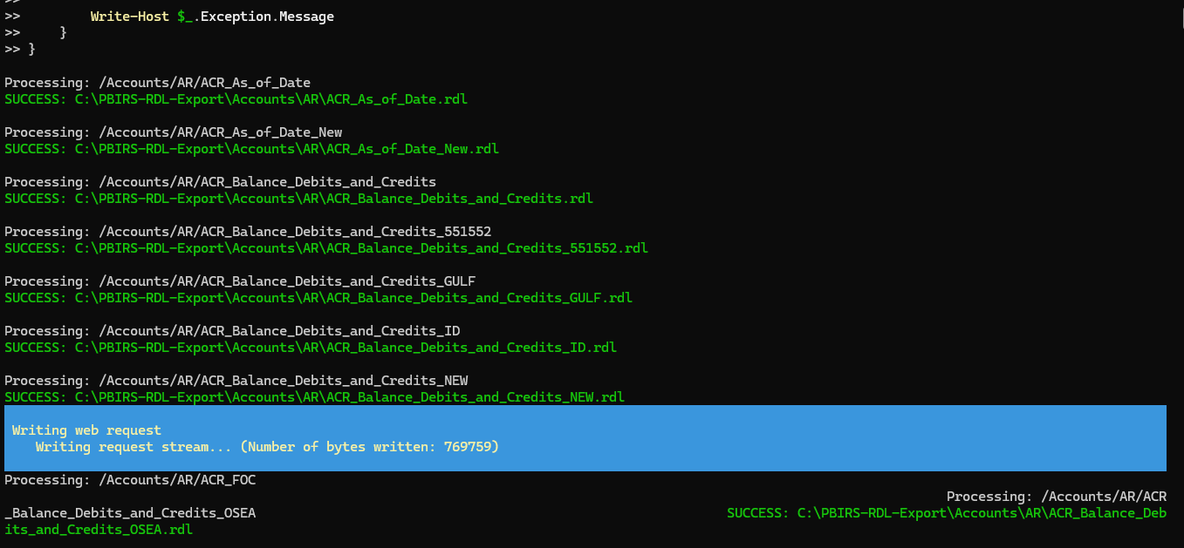

6. Create an inventory at the same time
For your migration project, don't just export the RDLs.
Create an inventory CSV as well.
This is extremely useful because you eventually need to know:
- Which RDL belongs to which folder
- Which database it connects to
- Which data source it uses
- Which reports are critical
- Which reports need migration remediation
Add this to the script:
$Inventory = @()

foreach ($report in $reports) {

$Inventory += [PSCustomObject]@{
ReportName = $report.Name
ReportId = $report.Id
Path = $report.Path
Format = $report.Format
}
}

$Inventory |
Export-Csv `
"$OutputFolder\RDL-Inventory.csv" `
-NoTypeInformation `
-Encoding UTF8
You then get:
C:\PBIRS-RDL-Export
│
├── Finance
├── HR
├── Sales
├── ...
└── RDL-Inventory.csv

7. Even better — extract the data source information
Since your objective is:
PBIRS → Power BI Service + Azure SQL Managed Instance
the next thing I'd recommend is extracting RDL data-source information.
You want an inventory like:
Report | Folder | Data Source | Server | Database
Sales.rdl | Finance | SQLDS01 | SQLVM01 | FinanceDB
Revenue.rdl | Finance | SQLDS01 | SQLVM01 | SalesDB
Invoice.rdl | Sales | SQLDS02 | SQLVM01 | BillingDB
This lets you determine:
Which reports point to SQL Server VM?
↓
Which databases do they use?
↓
Which reports need connection changes?
↓
Which reports can move directly?
That is particularly important in your case because you have 25 SQL databases.

8. Recommended migration folder structure in Azure DevOps
After export, I would organize your repository like this:
PowerBI-Paginated-Reports
│
├── Reports
│ │
│ ├── Finance
│ │ ├── Monthly
│ │ │ ├── Sales.rdl
│ │ │ └── Revenue.rdl
│ │ │
│ │ └── Annual
│ │ └── AnnualSales.rdl
│ │
│ ├── HR
│ │ ├── Employee.rdl
│ │ └── Payroll.rdl
│ │
│ └── Sales
│ └── Customer.rdl
│
├── Inventory
│ ├── RDL-Inventory.csv
│ └── DataSource-Inventory.csv
│
└── README.md
Then:
PBIRS
↓
PowerShell bulk export
↓
RDL repository
↓
Azure DevOps Git
↓
RDL Migration Tool / Power BI Service
Microsoft's RDL Migration Tool is specifically intended to migrate reports from Power BI Report Server/SSRS to Power BI Service.

One important distinction
If your RDLs are currently on PBIRS, use the PBIRS REST API approach above.
If you're instead asking to bulk-export RDLs that are already in Power BI Service, that's a different process: Power BI's REST API has an Export Report endpoint that can export reports as .rdl, and the workspace-specific API can retrieve reports from a workspace.
For your current PBIRS → Power BI SaaS migration, the first script is the appropriate direction.

how to convert the powershell script into a file and execute it
Sure. You can save the PowerShell commands as a .ps1 file and execute it.

1. Create the PowerShell file
Open Notepad or VS Code and paste your script:
$PBIRS = "https://PBIRS01/reports"

$Credential = Get-Credential

$uri = "$PBIRS/api/v2.0/Reports"

$response = Invoke-RestMethod `
-Uri $uri `
-Credential $Credential `
-Method Get

$response.value | Select-Object Id, Name, Path
Save it as:
Get-PBIRSReports.ps1
For example:
C:\Scripts\Get-PBIRSReports.ps1
Important in Notepad: select Save as type → All Files, otherwise it may become:
Get-PBIRSReports.ps1.txt

2. Open PowerShell
Open Windows PowerShell and go to the folder:
cd C:\Scripts
Check that the file exists:
dir
You should see:
Get-PBIRSReports.ps1

3. Execute the script
Run:
.\Get-PBIRSReports.ps1
PowerShell will display a credential prompt:
Windows PowerShell Credential Request

User: DOMAIN\username
Password: ********
Enter the account that has access to PBIRS.

4. If PowerShell says scripts are disabled
You may see:
cannot be loaded because running scripts is disabled on this system
Check your execution policy:
Get-ExecutionPolicy
For a temporary permission for the current PowerShell session, use:
Set-ExecutionPolicy -Scope Process -ExecutionPolicy Bypass
Then run:
.\Get-PBIRSReports.ps1
This does not permanently change the machine's execution policy.

5. For your actual RDL export
Once the above test works, save your bulk export script as:
Export-PBIRS-RDLs.ps1
Then execute:
.\Export-PBIRS-RDLs.ps1
I'd recommend putting the script and output like this:
C:\PBIRS-Migration\
│
├── Scripts\
│ └── Export-PBIRS-RDLs.ps1
│
└── Export\
├── Finance\
├── Sales\
├── HR\
└── RDL-Inventory.csv
That gives you a clean structure for subsequently putting the RDLs and scripts into Azure DevOps Git.
If you're going to run this against hundreds of RDLs, I can also give you a production-ready .ps1 that handles pagination, folders, credentials, RDL download, errors/retries, and CSV inventory.

